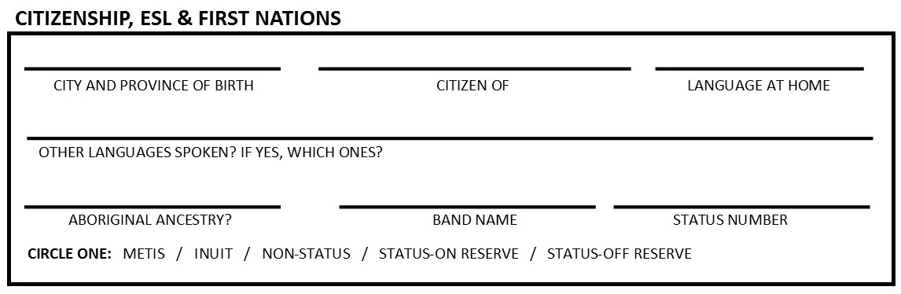
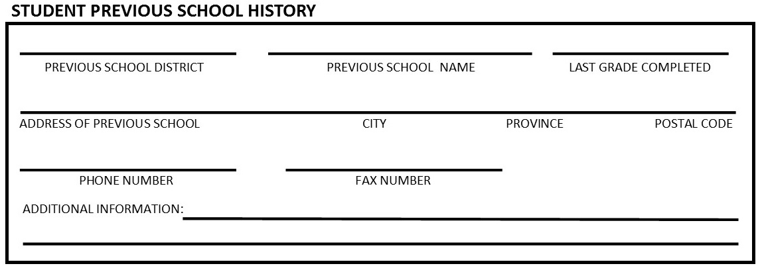
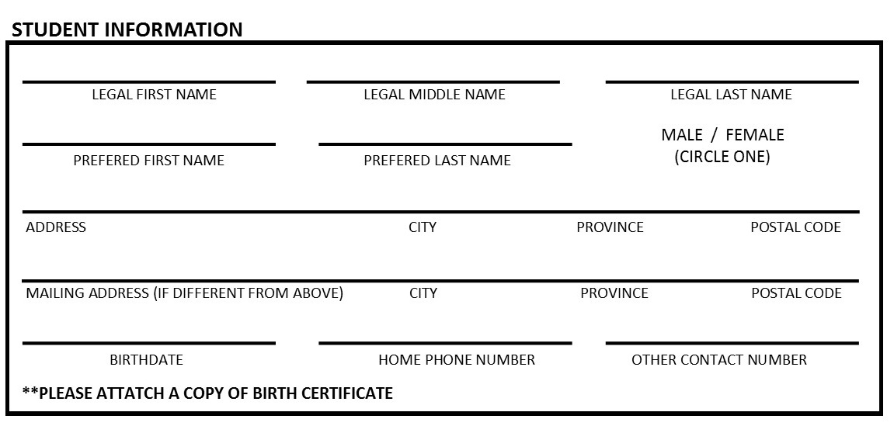
Arrowsmith Independent School
861 Hilliers Road, Qualicum Beach, BC V9K 1X5
Phone: 250-752-2722
www.arrowsmithindependentschool.ca
arrowsmithschool@shaw.ca

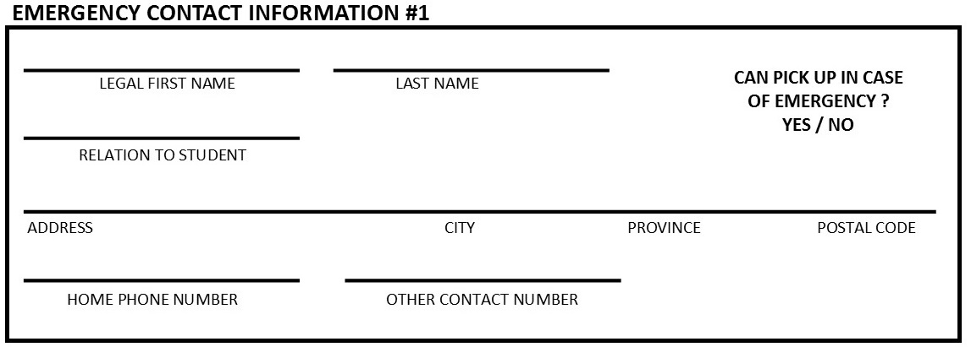
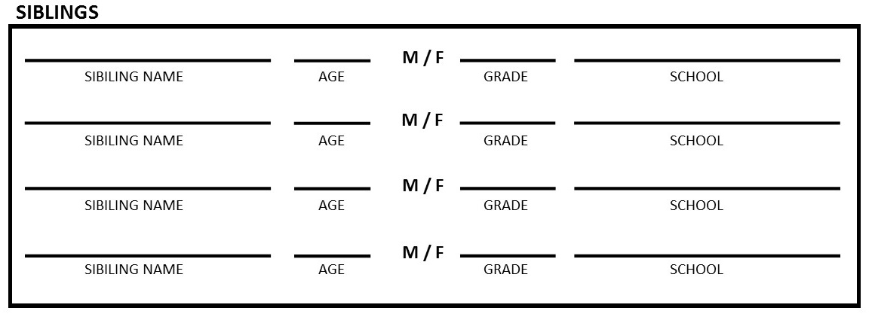

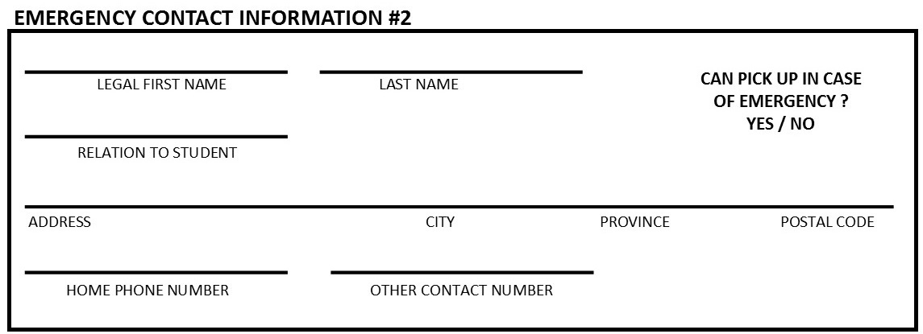

Date of Last Tetanus Shot_________________________

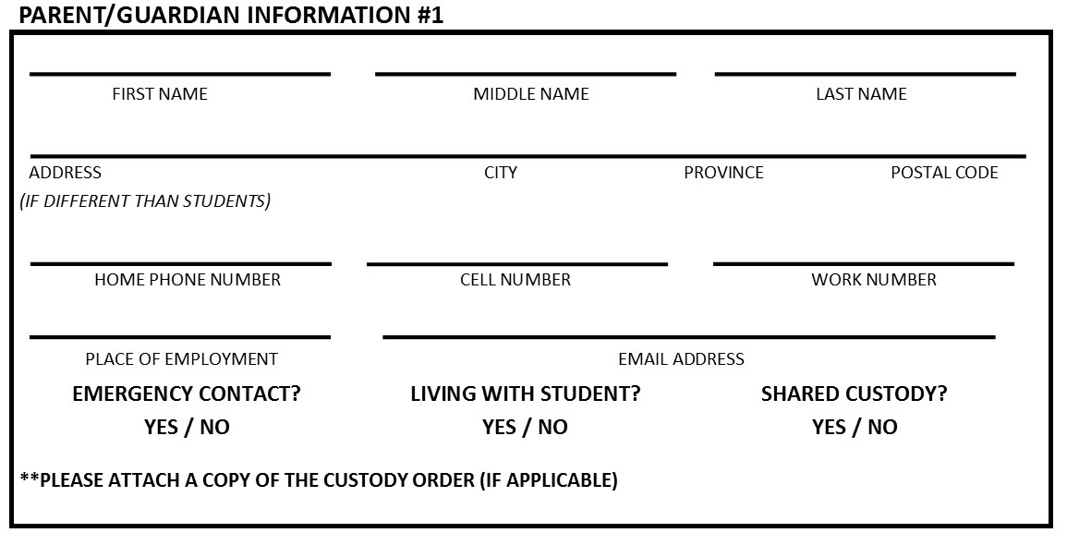

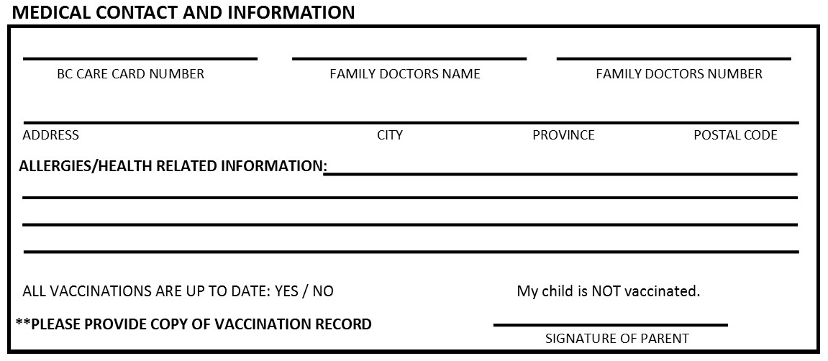
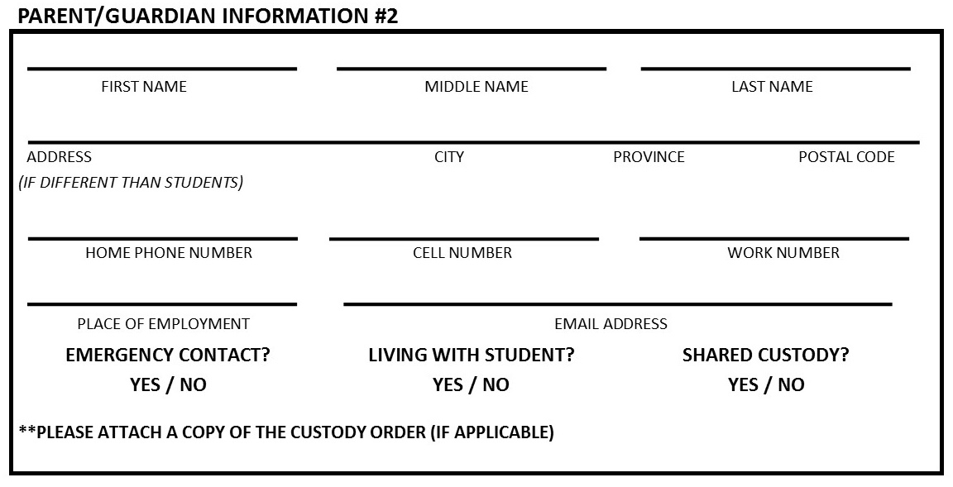
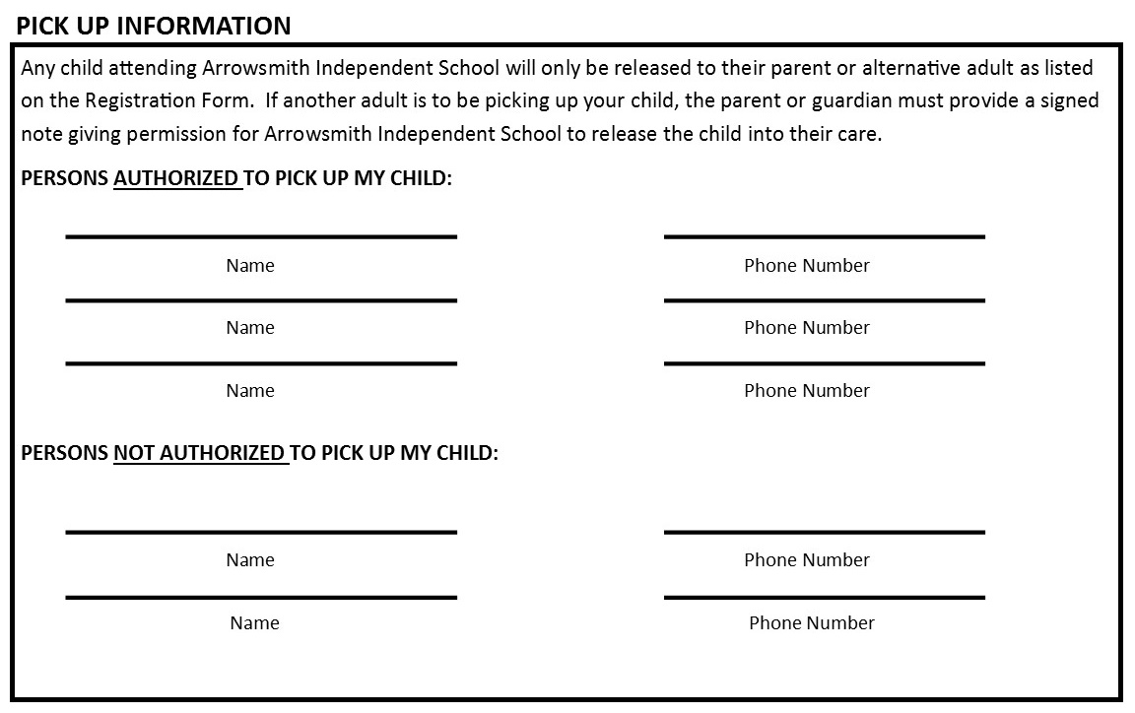

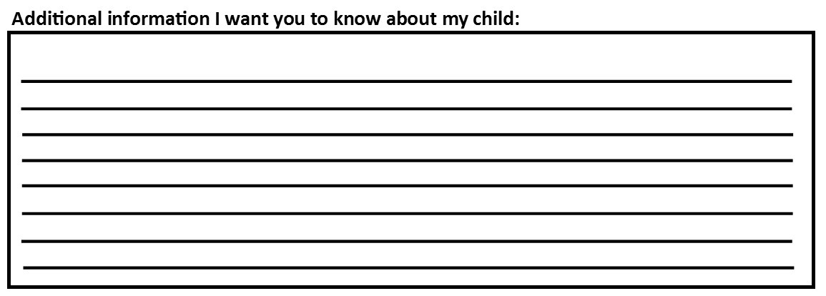

Child Release and Consent

PHOTO RELEASE
I consent to having photographs and work samples of my child used by Arrowsmith Indpendent School on their facebook page, website, newsletter and other promotional material. . YES/NO

Parent Signature:______________________________ Date:_____________________________

FAMILY CONTACT LIST CONSENT
The school will prepare a family phone list for the purpose of play dates, car pooling, etc. I give permission for my phone number and email address to be on the list. YES/NO

Parent Signature:_____________________________ Date:_____________________________

FIELD TRIP PERMISSION SLIP
It is our policy that we notifyand get written consent from parents when we go on a special field trip. This authorization covers only field trips in walking distance such as nature walks. I give permission for my child to participate in local field trips within easy walking distance, without prior notice. YES/NO

Parent Signature:_____________________________ Date:_____________________________

FIRST AID
I give permission for the school staff to administer basic first aid to my child’s minor concerns.
YES/NO
An ambulance may be called to transport and provide care for all major concerns.
YES/NO

Parent Signature:_____________________________ Date:_____________________________

VERBAL PERMISSION CANNOT BE ACCEPTED If the parent/guardian and the emergency contact cannot be reached in case of an emergency or for pick up, your child will remain with a teacher or staff member for 4 hours. If the parent/guardian or emergency contact still cannot be reached, the child will be released to the Ministry for protective custody. If any authorized person appears to be incapable of providing safe care (under the influence of drugs or alcohol or extremely emotional, etc.), Arrowsmith Independent School will NOT release your child to that person. The emergency contact or other authorized person will be called for pick up. If an authorized person cannot be contacted, the child will be released to the Ministry for protective custody.

Parent Signature____________________________ Date_______________________________

CONSENT TO COLLECTION OF PERSONAL INFORMATION
I consent to having Arrowsmith Independent School collect personal information that may include student identification information, birth certificate, legal guardianship, court orders if applicable, parents’ work numbers and email address, behavioural and health information, emergency contact numbers, doctor’s name and number, health insurance number and any similar information as needed for registration.
I further consent to the use and disclosure of information contained in this form and otherwise collected by or on behalf of Arrowsmith Independent School for the purpose of establishing, maintaining and terminating the student’s or parent’s relationship with Arrowsmith IndependentSchool, and as otherwise provided in Arrowsmith Independent School’s Personal Information Privacy Policy, a copyof which is available on request at the Main School Office from Arrowsmith Independent School’s privacy officers Shauna Bookout or Colleen Murray.

Arrowsmith Independent School acknowledges that there will be no disclosure of personal information to unauthorized personnel or third parties who are not directly involved in school managegment or the care, supervision and instruction of your child(ren) at this school, unless written authorization from a parent or legal guardian is provided to the school. The school will securely store all digital and hard copy parent and student personal information.

_____________________________ _________________________ __________________________
Signature of School Privacy Officer Title Date

Signature of Parent:_____________________________________ Date:_________________________

By signing below I agree that the information I have submitted on this form is correct to the best of my knowledge.

PARENT/GUARDIAN #1 FULL NAME SIGNATURE DATE

PARENT/GUARDIAN #2 FULL NAME SIGNATURE DATE

* It is the responsibility of the Parent/Guardian listed on this form to keep the information up to date and current.

FOR OFFICE COMPLETION
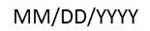
Enrolment Date: ______________ First Date Attended: ______________ Departure Date: __________

